 Form Fees Rs. 250/- Form No. ___________ 

|  |  |
| --- | --- |
| **Government Elementary College of Education (Women) Mirpurkhas**  **Admission Form for B.Ed (Hons.) Elementary**  **[Please fill the form in Capital Letters and Tick (✓) the Appropriate box]** | Photograph |
|  |

|  |  |  |  |  |  |  |  |  |  |
| --- | --- | --- | --- | --- | --- | --- | --- | --- | --- |
| **Category of Application**: | Urban |  | Rural |  | **Gender**: | Male |  | Female |  |

|  |  |  |  |  |  |  |  |  |  |  |  |  |  |  |  |  |  |
| --- | --- | --- | --- | --- | --- | --- | --- | --- | --- | --- | --- | --- | --- | --- | --- | --- | --- |
|  |  |  |  |  |  |  |  |  |  |  |  |  |  |  |  |  |  |

Name of Applicant:

|  |  |  |  |  |  |  |  |  |  |  |  |  |  |  |  |  |
| --- | --- | --- | --- | --- | --- | --- | --- | --- | --- | --- | --- | --- | --- | --- | --- | --- |
|  |  |  |  |  |  |  |  |  |  |  |  |  |  |  |  |  |

Father’s/Guardian’s Name:

|  |  |  |  |  |  |  |  |  |  |  |  |  |  |  |  |  |  |  |
| --- | --- | --- | --- | --- | --- | --- | --- | --- | --- | --- | --- | --- | --- | --- | --- | --- | --- | --- |
|  |  |  |  |  |  |  |  |  |  | Date of Birth: |  |  |  |  |  |  |  |  |

Surname:

|  |  |  |  |  |  |  |  |  |  |  |  |  |  |  |  |  |  |  |  |  |  |  |  |  |  |  |  |  |
| --- | --- | --- | --- | --- | --- | --- | --- | --- | --- | --- | --- | --- | --- | --- | --- | --- | --- | --- | --- | --- | --- | --- | --- | --- | --- | --- | --- | --- |
| Religion: |  |  |  |  |  |  |  |  |  | Nationality | | | |  | |  | |  | |  |  |  |  | |  |  |  | |
|  |  | | | | | | | | | | | | | | | | | | | | | | | | | | |
| CNIC: |  |  |  |  |  | - |  |  |  | |  |  |  |  | - | |  | | Blood Group | | | | |  | | | | |

|  |  |  |  |  |  |  |  |  |  |  |  |  |  |  |  |  |  |  |  |
| --- | --- | --- | --- | --- | --- | --- | --- | --- | --- | --- | --- | --- | --- | --- | --- | --- | --- | --- | --- |
| Father’s/ Guardian’s Occupation |  |  |  |  |  |  |  |  |  |  |  |  |  |  |  |  |  |  |  |

|  |  |  |  |  |  |  |
| --- | --- | --- | --- | --- | --- | --- |
| **Marital Status**: | Married |  | Unmarried |  | Email: |  |

|  |  |  |  |  |  |  |  |  |  |  |  |  |  |  |  |  |  |  |  |  |  |  |  |  |  |
| --- | --- | --- | --- | --- | --- | --- | --- | --- | --- | --- | --- | --- | --- | --- | --- | --- | --- | --- | --- | --- | --- | --- | --- | --- | --- |
| Postal Address: |  |  |  |  |  |  |  |  |  |  |  |  |  |  |  |  |  |  |  |  |  |  |  |  |  |

|  |  |  |  |  |  |  |  |  |  |  |  |  |  |  |  |  |  |  |  |  |  |  |  |  |  |  |  |  |
| --- | --- | --- | --- | --- | --- | --- | --- | --- | --- | --- | --- | --- | --- | --- | --- | --- | --- | --- | --- | --- | --- | --- | --- | --- | --- | --- | --- | --- |
|  |  |  |  |  |  |  |  |  |  |  |  |  |  |  |  |  |  |  |  |  |  |  |  |  |  |  |  |  |

|  |  |  |  |
| --- | --- | --- | --- |
| Contact No(s): student &. Father |  | Cell No: Student & Father |  |

Academic Record:

|  |  |  |  |  |  |  |  |
| --- | --- | --- | --- | --- | --- | --- | --- |
| Name of Examination | Group | Name of Board / University | Passing Year | Seat No, | Annual/ Suppl: | Grade/  Division | Marks Obtained |
| SSC Pass Part-II |  |  |  |  |  |  |  |
| HSC Pass Part-II |  |  |  |  |  |  |  |
| Bachelor’s Degree |  |  |  |  |  |  |  |
| Master’s Degree |  |  |  |  |  |  |  |
| Other (if any) |  |  |  |  |  |  |  |

___________________________________ _____________________________

**Date** **Signature of Candidate**

…………………………………………………………………………………………………………………………

Receipt

Received the admission form along with the required documents. Form No. _____________

Date: ______________________

Name: ______________________ Designation: _________________________

____________________________

**Signature & Stamp**

**UNDERTAKING**

1. I solemnly affirm that I shall abide by the rules and regulations of the College, Education and Literacy Department and affiliated University framed from time to time.
2. I shall not participate in any political activities.
3. I shall not participate in any anti-social / criminal activity.
4. I shall not misconduct with college authorities, faculty and other students/ colleagues.
5. I shall remain regular and punctual.
6. I shall submit assignments and participate in educational/ re-creational activities.
7. I shall appear in tests and examinations as per schedule.
8. I have not taken admission in any other regular program.

_________________________ ___________________

Signature of Father/ Guardian Signature of Student

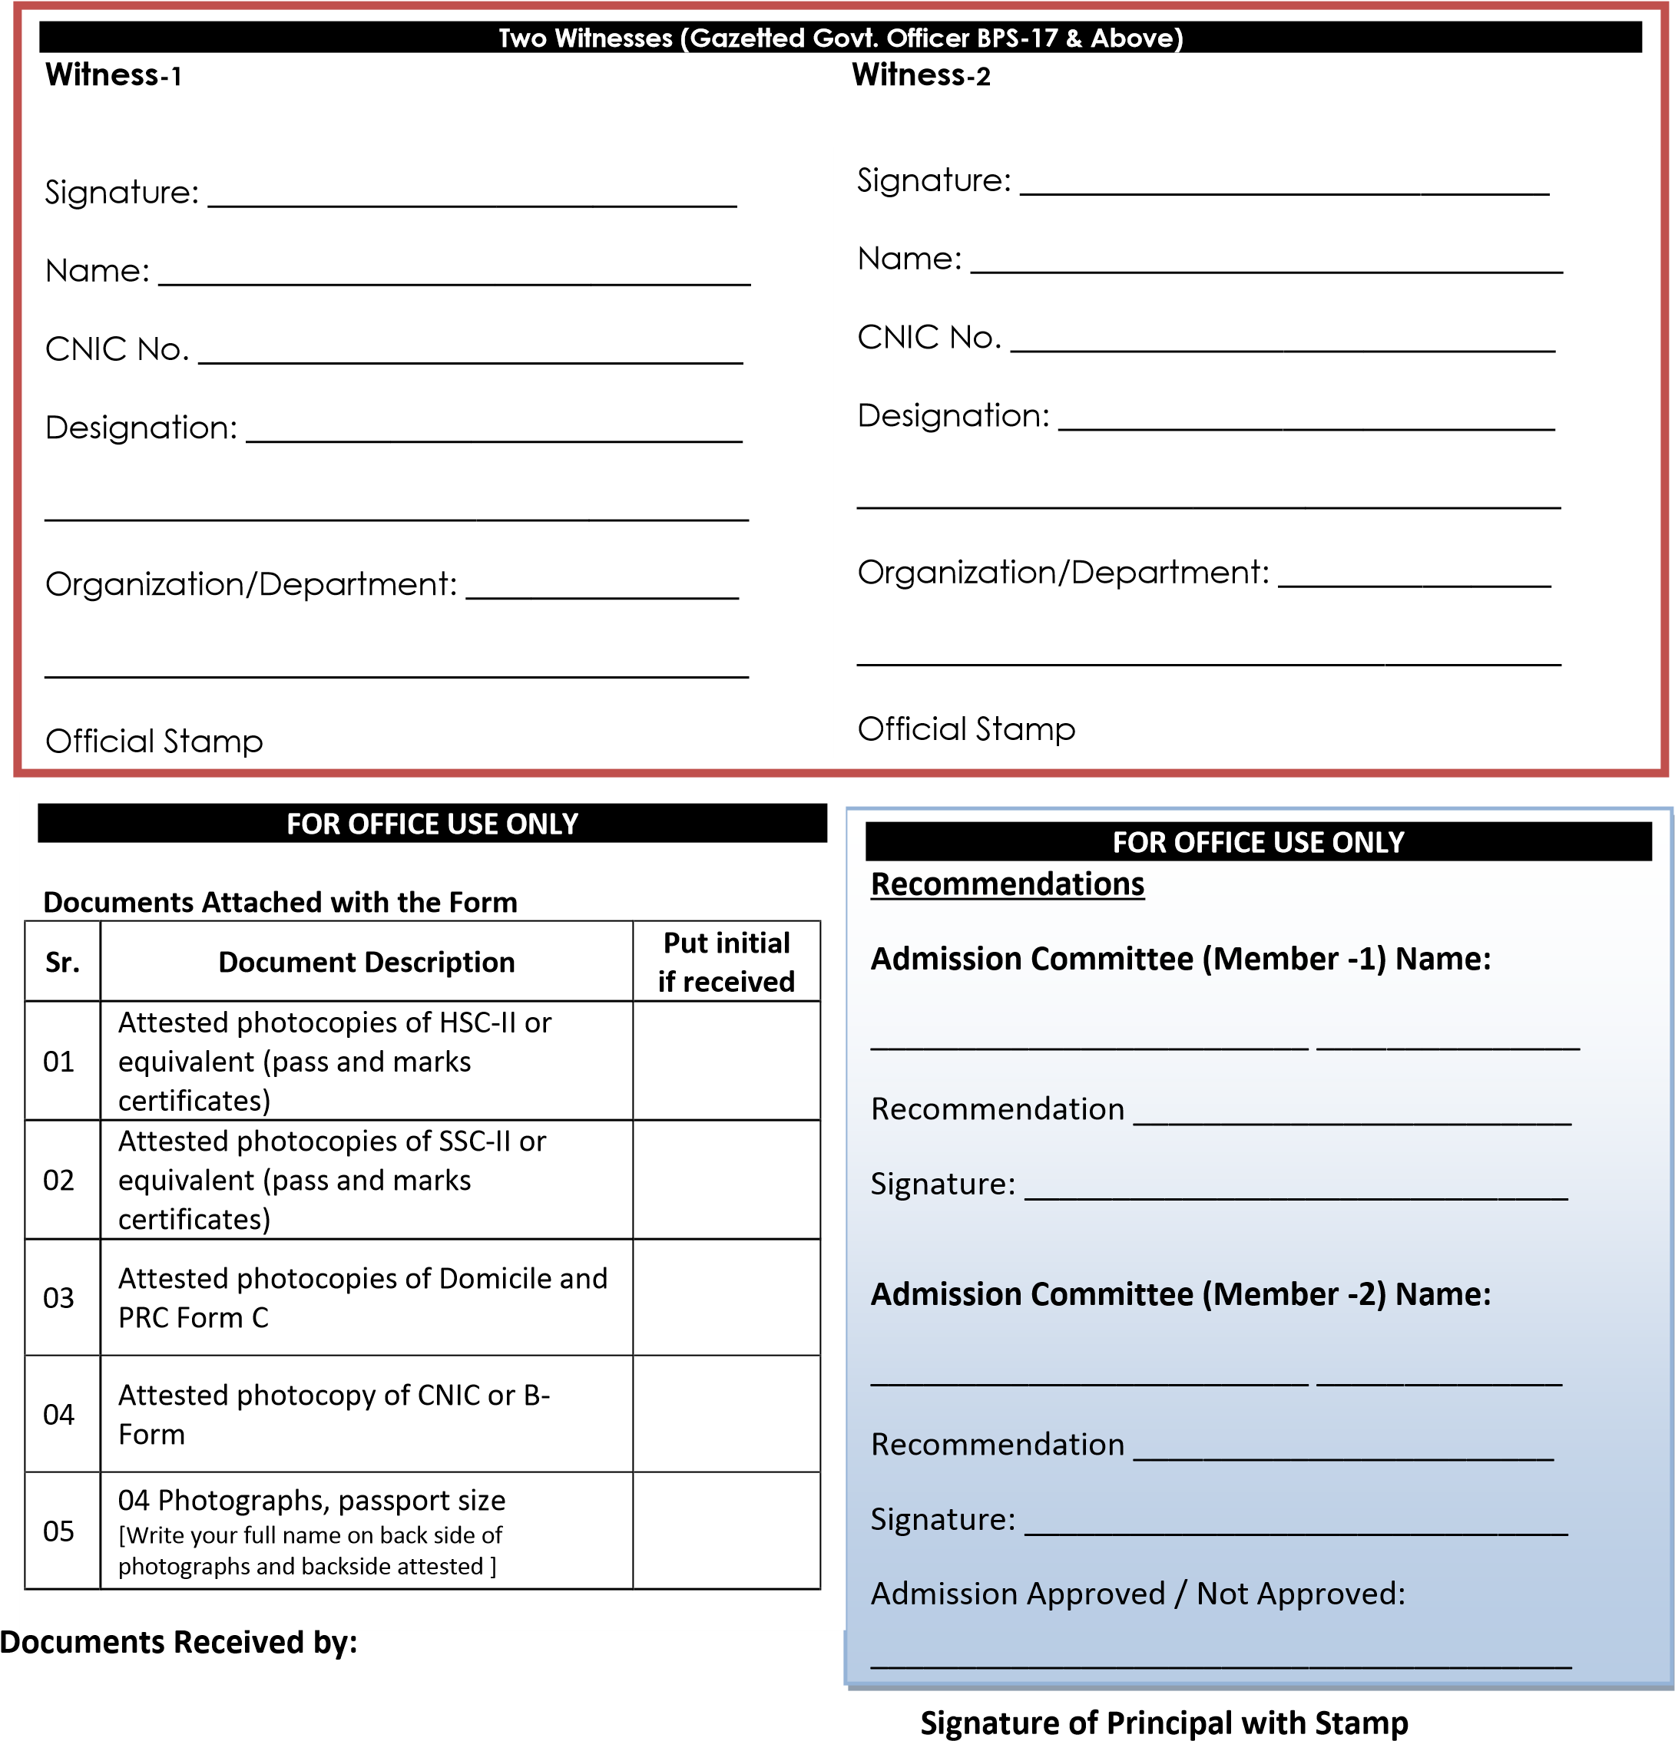

**Check List**

**Tick (✓) if you have done as stated:**

|  |  |  |
| --- | --- | --- |
|  |  | **Yes** |
| 1. | One attested copy of matriculation **Pakka** Certificate/ Marks Sheet attached. |  |
| 2. | One attested copy of HSC **Board Pass** Certificate/ Marks Sheet attached. |  |
| 3. | One attested copy of Domicile attached. |  |
| 4. | One attested copy of PRC Form © attached. |  |
| 5. | One attested copy of CNIC/B-Form of the candidate attached. |  |
| 6. | One attested copy of Fatter/Mother/Guardian CNIC attached. |  |
| 7. | Four attested copies of Passport size Photographs with **WHITE Background** attached. |  |
|  | (write your full name on back side of photographs) |  |
| 8. | Any other document(s) attached __________________________________________________ |  |

**Verified by:** Name ________________________ Designation: ___________________ _________________

Signature

|  |  |  |
| --- | --- | --- |
| FOR OFFICE USE ONLY | | |
| **Recommendations**  Admission Committee (Member-1)  Recommendation _____________  Admission Committee (Member-2)  Recommendation _____________  Admission Approved/ Not Approved | Name:_______________________  Signature:____________________  Name:_______________________  Signature:____________________ | Roll No. ___________________  Date of Admission: __________  Section: __________________ |
| Date:_____/____/________ |  | ____________________  Principal |